1 Introduction

After several decades of well-documented decline in Arctic sea ice coverage, summertime extent is now ~40% lower than that observed in the late 1970s (Kwok and Rothrock, 2009; Comiso, 2012; Frey et al., 2015; Grebmeier et al., 2015). Replacement of the multiyear ice pack with first-year ice has caused a decline in sea ice thickness of 65%, from a mean of 3.59 m in 1975 to just 1.25 m in 2012 (Richter-Menge and Farrell, 2013; Lindsay and Schweiger, 2015). Besides being thinner, first-year ice typically accumulates less snow (Webster et al., 2014) and has higher pond areal coverage (Perovich and Polashenski, 2012) than multiyear ice. The high-albedo ice cover controls the transmittance of ultraviolet and visible light to the water column, such that changes in sea ice conditions lead to significant alteration in the timing and magnitude of solar radiation introduced to the upper Arctic Ocean. The magnitude and availability of light is at least partially responsible for the heat budget of the upper ocean, phenology of pelagic primary production, and carbon cycling within the water column.

The WARM (WArming and irRadiance Measurements in the Arctic, 2012 - 2015) autonomous drifting platforms were designed to provide the observations necessary to address questions related to the impact of changing sea ice conditions on solar-driven processes. The data are being used to investigate water column heating, the evolution of the under-ice light field, primary production related to thinning sea ice, and photochemistry of dissolved organic material.

Here we propose a new project to build on the work begun in WARM phase 1, improving the design of the WARM buoy and continuing our observing program. The ice-based WARM buoys have proven to be robust and capable of surviving ice melt, recording light, temperature and biological parameters throughout spring, summer, and fall. The data collected have covered temporal (hourly observations from early spring through autumn) and spatial (under ice, across shelf systems) scales that are not possible by other means, (e.g., ship, moorings, or satellites). The measurements from this buoy capture processes close to the underside of first-year pack ice, and include detailed observations during ice break-up. These measurements are central to the mission of the Arctic Observing Network, and are not provided by other ice-based systems.

2 Background

Sea ice loss increases the areal coverage of low-albedo open water, enhancing the absorption of solar radiation in surface waters and resulting in warming. Additionally, thinner and more ponded ice effectively transmits solar radiation directly to the ocean (Perovich et al., 2008), accelerating warming and ice melt, further reducing surface albedo and leading to a negative feedback loop in which more ice is lost. Sea surface warming trends in the Arctic Ocean (AO) have been most pronounced in the Chukchi and Beaufort seas, with recent summertime temperature anomalies as large as 2.5°C (Steele et al., 2008; Timmermans and Proshutinsky, 2015). Analysis of solar heating by Perovich et al., (2007) revealed that the largest increase in solar heat input to the Arctic Ocean over the last 30 years also occurred in that region. It is estimated that local solar driven heating accounts for 70 – 80 % of ocean heating and ice melt in the Chukchi and Beaufort Seas (Steele et al., 2011; Woodgate et al., 2010). Thus, transmission of solar radiation to the water column either through sea ice or open water is thought to be the dominant driver for temperature increases in the western AO. Solar radiation input after ice has retreated warms and stratifies surface waters, further inducing ice retreat and delaying fall freeze-up. When solar radiation penetrates the sea ice cover, it heats waters below the thin, cold surface melt layer, creating a Near Surface Temperature Maximum (NSTM). In recent years this NSTM has persisted through the winter (Jackson et al., 2012; Steele et al., 2011), suppressing winter ice growth rates especially during storms (Jackson et al., 2012; Timmermans, 2015).

Temperature effects
Water column temperature is considered to be a main driver of ecosystem changes. Thermal stratification set up by local radiatively forced heating can limit the vertical replenishment of nutrients, affecting the magnitude of both primary production (Wassmann and Reigstad, 2011), and consumer populations. However, not all temperature impacts are physical; as increases in water temperature also play a fundamental role in driving biological processes and setting thresholds for abundance and distribution (Wassmann et al., 2011). A recent study on the effects of thermal stress on phytoplankton found that 5 – 6 °C was the thermal threshold for Arctic species after which abundance and growth rates decrease. Such decreases may cause these species to be outcompeted by sub-Arctic species (Coello-Camba et al., 2015). Changes in seasonal temperature ranges have also been shown to impact the geographical distribution of zooplankton species. A 1°C increase in temperature can shift sub-Arctic species northwards and cause Arctic species to contract further into the AO (Beaugrand et al., 2002). Because zooplankton are highly sensitive to temperature for all physiological processes, increases in temperature impact abundance and trophic efficiency (Richardson, 2008 and references therein). Changes in the phenology of zooplankton abundance due to warmer water are postulated to cause a mismatch between producers and consumers, leading to rearrangement of food webs and communities (Ji et al., 2013). The opportunity to collect measurements to both monitor water column temperature and improve our understanding of solar driven heating will advance our predictive capabilities in a changing Arctic environment.

Phenology of primary production
The timing or phenology of primary production in the Arctic is driven by light availability. A thinner ice cover, with less snow and more ponded area increases the transmission of light to the upper water column, deepening the euphotic layer, and increasing the light available for photosynthesis and net primary production (NPP). Recent observations of high under-ice phytoplankton concentrations ~100 km from the ice edge may be an indication of a changing net primary productivity (NPP) regime in which water column phytoplankton growth can be initiated and sustained under the ice (Arrigo et al., 2012; Churnside and Marchbanks, 2015). If so, then the Arctic-wide shift from multiyear to seasonal ice could cause a shift in the timing of the spring bloom. The consumption of surface nutrients by under-ice blooms can cause nutrient limitation to occur before the marginal ice zone (MIZ) arrives, greatly diminishing NPP in an area where it has historically been the highest (Palmer et al., 2014). Although under-ice blooms may have little to no effect on total seasonal production (Palmer et al., 2014), the shift in the relative NPP in ice covered versus open water has implications for pelagic vs. benthic food webs. Even a small timing mismatch between phytoplankton blooms and zooplankton reproductive cycles can have consequences for the entire lipid-driven Arctic marine ecosystem (Soreide et al., 2010; Leu et al., 2011; Ji et al., 2013; Leu et al., 2011), as early phytoplankton production could go ungrazed by zooplankton. The combined effects of reduced ice on light availability and nutrient replenishment (through enhanced upwelling) may substantially increase NPP in specific areas such as shelf-breaks and weakly stratified seas. Some areas of the Arctic are now experiencing a second fall bloom initiated by storm mixing (Ardyna et al., 2014), which is more indicative of temperate ecosystems. Observations of light and phytoplankton abundance throughout the growing season will enable determination of the potential magnitude of under-ice NPP relative to open water and total annual NPP.

Under-ice blooms can also have significant effect on our ability to accurately estimate total annual water column production, as the under-ice environment is not accessible by satellite-based sensors. Surface nutrient limitation under the ice forces phytoplankton deeper to the nutracline (Martin et al., 2010) where it is invisible to ocean color sensors which only observe surface signatures (Hill and Zimmerman, 2010). In this scenario, autonomous ice based systems will play an important role in continuing our monitoring of lower trophic level production.

Photochemistry in the Arctic
Earlier sea ice melt increases open water area which permits more ultraviolet (UV) radiation to reach the upper water column. The melt season length has increased across the entire Arctic, with the Chukchi Sea experiencing an increase in open water duration of about 7 days per decade over the last 30 years (Markus et al., 2009). As the duration of UV exposure of the upper Arctic Ocean increases it will increase the importance of photochemistry for direct remineralization of terrestrial and marine organic matter. Photochemistry on the colored dissolved organic material (CDOM) pool plays an important role in chemical and biological processes, by degrading refractory compounds to CO, CO₂, DIC and biologically labile DOM compounds (Kieber et al., 1989; Mopper et al., 1991) that can be used by microbes. The formation of biological substrates through photochemistry may also act to enhance bacterial production in carbon limited regions (Kieber et al., 1989). Determination of the transformation of exported terrestrial carbon, including the photochemical production of dissolved inorganic carbon (DIC) which is a major product of CDOM photochemistry is considered critical in determining the impact of climate change on the marine carbon cycle (Belanger et al., 2006). The high frequency measurements of light and fluorescent dissolved organic matter (fDOM) made from the WARM buoys can provide essential parameters to estimate photochemical rates in the Arctic Ocean.

3 results from WARM

Title: Collaborative research: Warming and irradiance measurements in the Arctic: determining the link between solar energy absorption and surface warming through long term observations. Award Numbers: 1203784 (ODU), 1203440 (UW). Period: 31/8/2012 to 1/9/2015. PI: Victoria Hill, Bonnie Light, Mike Steele. Data from this project are submitted to ACADIS (search for PI V. Hill). Location and temperature data from all buoys are also available in real time at http://psc.apl.washington.edu/UpTempO/.

Deployments: Four proof-of-concept buoys were deployed, two each in the spring of 2014 and 2015 (Fig 1 & Fig 2). Some thermistor failures were experienced in year 1 which were resolved in year 2 through extensive low-temperature troubleshooting. The WARM buoys have now proven to be extremely robust, surviving melting out of the ice and ridging events. The longest surviving buoy to date (WARM#1) reported data for 10 months (Fig 2A). WARM#2 transmitted for 8 months
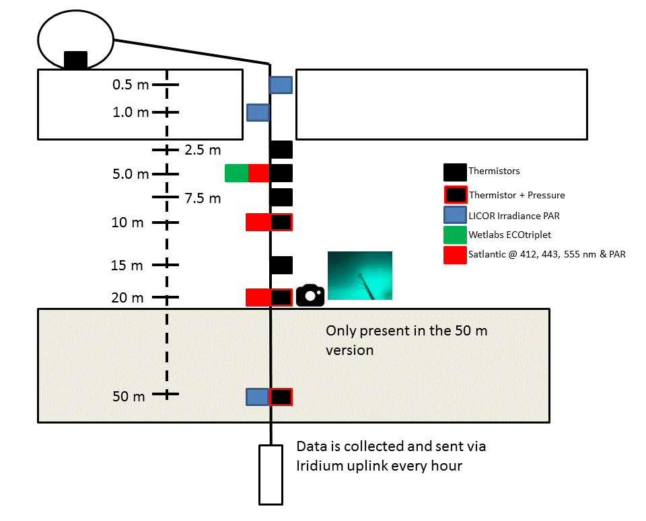

Figure 1. Diagram of buoy after deployment, float has a 3 m hortizontal displacement from the ice hole.

until the tether was severed in an ice rafting event on the coast of Svalbard (Fig 2B), however, it continued transmitting sea surface temperature (SST) and location for a further 9 months until it was retrieved on an Icelandic beach. WARM#3 and WARM#4 were deployed in 2015 north of Prudhoe Bay, AK (Fig 2C). WARM#3 is still transmitting data as we await freeze-up. WARM#4 suffered damage to the tether during a ridging event in May 2015 (Fig 2C), but continues to transmit SST and light data from the uppermost 2 meters. The data collected from these four deployments have been central to formulating answers to the following four questions:

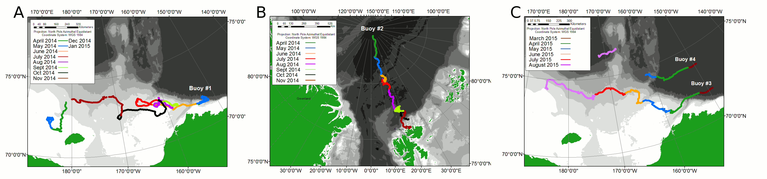
Figure 2. Drift tracks of buoys deployed during field seasons in 2014 and 2015.

How is the source of heat in the Arctic water column attributed?

The WARM buoy has both thermistors and radiation sensors providing a measure of ocean warming and also of the primary forcing for this warming in areas away from strong ocean and atmospheric advection (e.g., Steele et al., 2010). Some thermistors during Year 1 deployments experienced leakage, so here we analyze some early results from a Year 2 buoy (#3) in which all sensors worked through the spring and summer. The WARM buoy is deployed on ice, with the hull several meters laterally away from the drilled hole where the string is installed. The thermistor on the hull thus provides a measure of air/snow/ice temperatures until melt-out drops the sensor string ~3 m lower into the ocean. During the spring, thermistors in the ocean read uniformly low, freezing temperatures. (The longer-string buoy usually detects warmer temperatures at 50 m depth, indicating the top of the summer Pacific Water layer, e.g., Steele et al., 2004). Fig 3A shows melt-out of WARM buoy #3 on July 14, and strong diurnal temperature variations before and after this event, a response to diurnal solar forcing (Fig 3B). Minimum diurnal SST values after melt-out are ~ 0°C, indicating that the buoy likely floated in a pool of fresh melt water on top of the colder, saltier ocean water (salinity measurements are part of our proposed enhancements for the next phase of WARM). Buoy speed was relatively slow at this time, implying calm conditions that allowed for positive thermal stratification. On August 8, the buoy accelerated and SSTs cooled while subsurface ocean temperatures warmed, indicating increased mixing and reduced thermal stratification. This is the very start of summer NSTM formation (Fig 3C), an exciting process captured for the first time with this buoy. The nascent NSTM is mixed away by late August, although it re-appears in late September during the cooling phase.

A calculation of the expected ocean warming from shortwave radiation ΔT_{SW} at 7.5 m depth (mid-July - mid-September) gives ~ 2°C. This agrees very well with the total observed warming ΔT_{obs} over this period, although Fig 3C also shows temporal variations that are likely due to advection from small-scale thermal variations both in the vertical and horizontal.

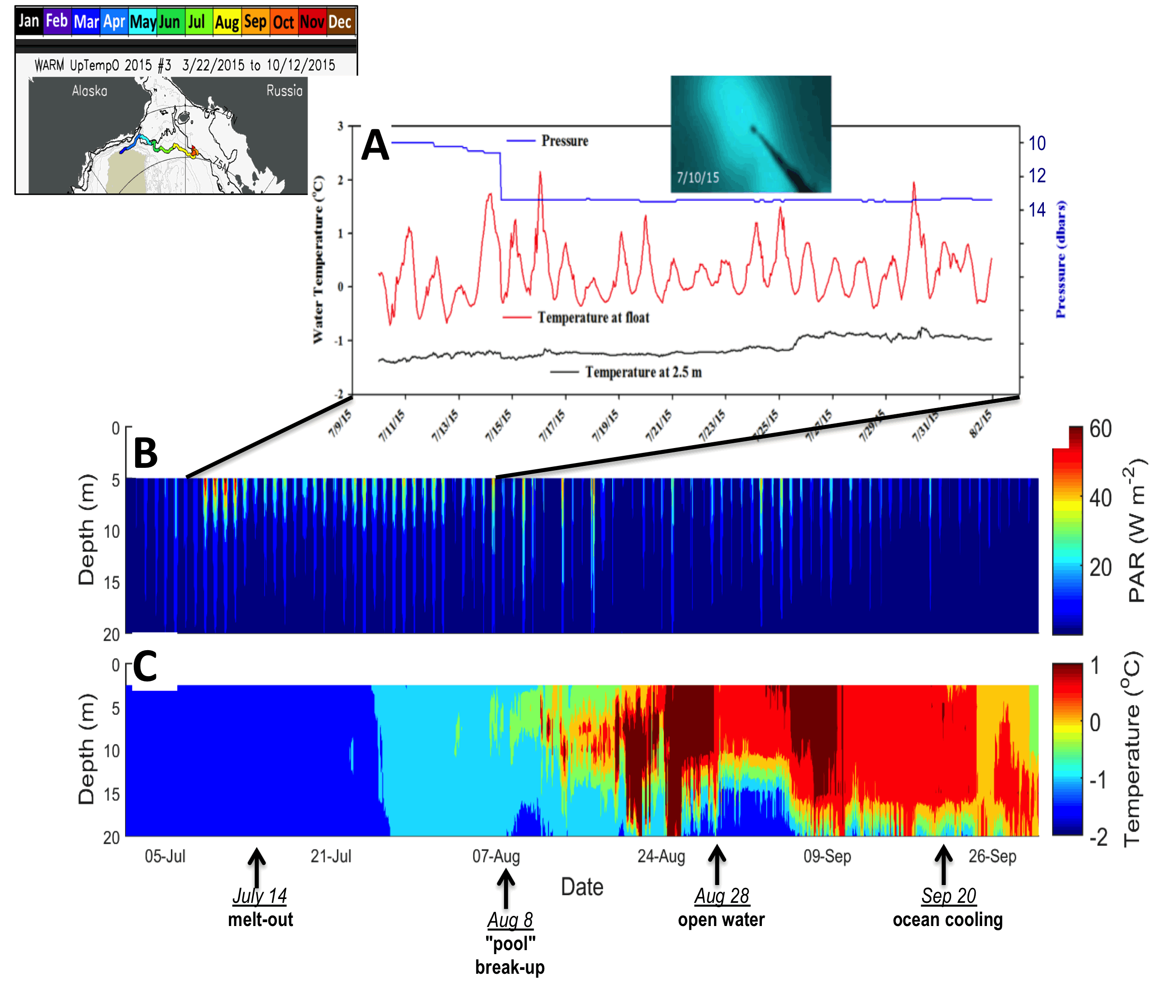

Figure 3. Drift track of WARM buoy #3 (upper left). (A) Upper ocean pressure sensor time series (blue) showing melt-out on July 14, float temperature (red) which becomes SST after melt-out, and ocean temperature below the surface (black). Also shown is a buoy image from July 10 (taken from the upward looking camera mounted at 20 m depth), showing a thinning area (light color) above the sensor string, surrounded by thicker ice (dark color). (B) Hourly PAR at 5 m, 10 m, and 20 m depths. (C) Ocean temperatures, showing transient NSTM formation in August and again in late September.
What is the seasonal progression of light attenuation under the ice and in open water?

WARM captured the first autonomous observations of massive under-ice phytoplankton blooms, a phenomenon just recently recognized as significant via a much more expensive ship-based study (Arrigo et al., 2012). High concentrations of phytoplankton biomass (8 to 15 mg m⁻³) were observed under the ice at distances of over 100 km from the marginal ice zone (Fig 4A & C). These “blooms” were observed within the top 20 m of the water column early in the year (June and July) and at a time when beneath-ice solar radiation fluxes were still relatively low (Fig 4B). Light penetration within the water column was linked to the evolution of these blooms and the presence of colored dissolved organic material (CDOM). Early in the spring (March - June) absorption of light was dominated by CDOM (Fig 4D), but because the radiation flux was extremely low during this period we saw no water column heating (not shown). The spectral irradiance information collected by the buoy allows us to calculate the chlorophyll concentration (Fig 4C) and CDOM absorption (Fig 4D) between light sensor depths (5 to 10 m and 10 to 20 m) using an inversion model of the diffuse attenuation coefficient. This enables us to separate the absorption of light by phytoplankton and CDOM (Fig 4D). This technique will provide the ability to calculate the absolute energy absorbed by each component which will enable us in the future to determine the amount of heating linked to the CDOM pool.
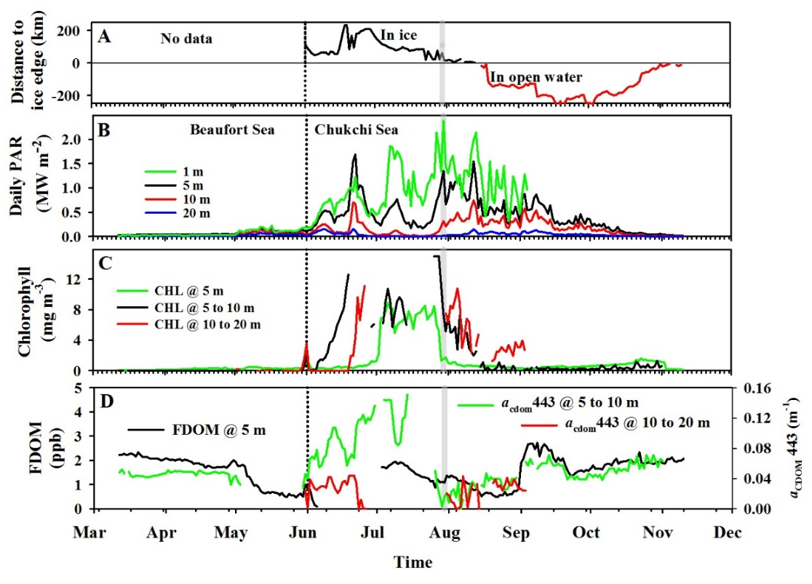
Figure 4. Data from buoy#1 deployed Beaufort Sea March 2014. A) Distance of buoy from ice edge, B) Daily PAR incident on each irradiance sensor, C) Chlorophyll concentration at the 5 m sensor depth and chlorophyll concentration between 5 and 10 m and 10 and 20 m calculated through inversion of the spectral diffuse attenuation data, D) fDOM concentration measured at the 5 m depth and CDOM absorption coefficient at 44 nm modeled through inversion of the spectral diffuse attenuation data.
Is there enough light to support photosynthesis beneath the ice?

Observations of light availability enable us to investigate potential photosynthesis by phytoplankton under the ice. Using observations of light under the ice a daily supported growth rate can be predicted. Light intensity observed under the ice during sections 1 and 2 (May through June) was sufficient to support growth from a late winter [Chl a] of 0.01 mg m⁻³ to the 10 mg m⁻³ that was observed between 5 and 10 m starting in the 2nd week of June (Fig. 5). Without grazing phytoplankton growth to a high of 30 mg m⁻³ at the surface could be supported before nutrient limitation would cause a decline in biomass (v). When grazing was initiated at [Chl a] of 5 mg m⁻³ [Chl a] started to plateau from mid-June and continue at approximately 9 mg m⁻³ throughout July, matching the observations from both the fluorometer and retrieved Chl a (Fig. 5). At the beginning of July observations of [Chl a] at 5 m reduced to below 5 mg m⁻³, however, the model supports a sustained biomass of approximately 9 mg m⁻³, until mid-August when concentrations start to decline (Fig. 5).
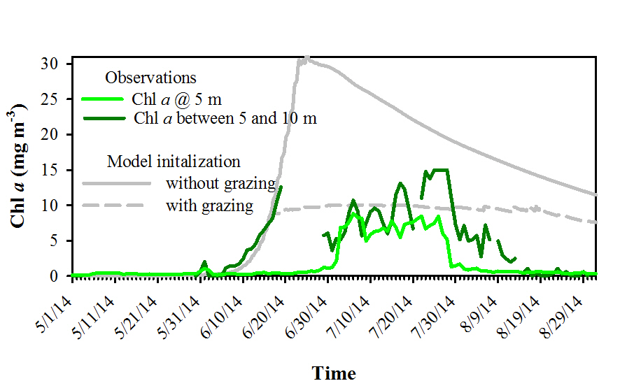
Figure 5. Observed and modeled Chl a concentration for the time period 5/1 to 9/3. Observations were taken at the 5 m fluorscence sensor, and using Kd between 5 and 10 m. Modeled Chl a is presented at 5 m, using intial conditions set to 0.01 mg m-3. In the grazing scenario, grazing pressure on the phytoplankton population was initiated at 97% of net growth once chlorophyll concentrations reached 5 mg m-3

