Image # | Image | Common Name | Scientific Name | Phylum | Other Taxa
A-1 | 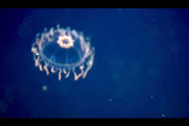 | Jelly  Hydromedusa | Arctapodema sp. | Cnidaria | Class Hydrozoa  Subclass Trachymedusae
A-2 | 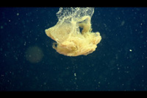 | Larvacean house  Sinker | Bathochordaeus sp. | Chordata | Subphylum Urochordata
A-3 | 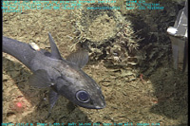 | Rat tail | Coryphaenoides acrolepis | Chordata | Class Chondrichthyes
A-4 | 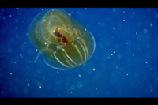 | Lobate comb jelly | Lampocteis sp. | Ctenophora | Order Lobata
A-5 | 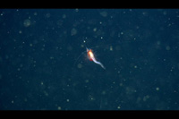 | Mysid shrimp | Mysidella americana | Arthropoda | Class Crustacea  Order Mysidacea
A-6 | 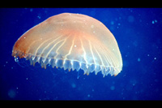 | Jelly  Scyphomedusa | Poralia rufescens | Cnidaria | Class Scyphozoa
A-7 | 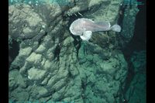 | Blob sculpin | Psychrolutes phrictus | Chordata | Class Osteichthyes
A-8 | 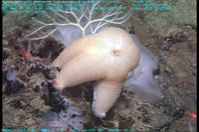 | Sea star | Pteraster sp. | Echinodermata | Class Asteroidea
A-9 | 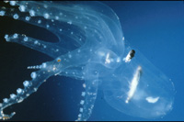 | Transparent octopus | Vitreledonella richardi | Mollusca | Class Cephalopoda
A-10 | 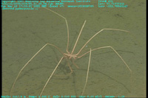 | Sea spider |  | Arthropoda | Class Pycnogonida
A-11 | 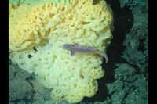 | Sponge |  | Porifera
A-12 | 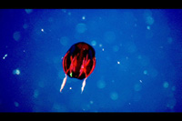 | Cydippid comb jelly |  | Ctenophora | Order Cydippida
B-1 | 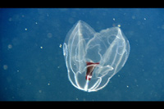 | Lobate comb jelly | Bathocyroe fosteri | Ctenophora | Order Lobata
B-2 | 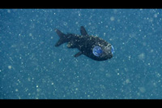 | Owlfish  Blacksmelt | Bathylagus milleri | Chordata | Class Osteichthyes
B-3 | 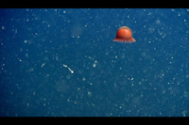 | Jelly  Hydromedusa | Benthocodon sp. | Cnidaria | Class Hydrozoa  Subclass Trachymedusae
B-4 | 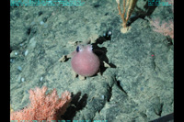 | Octopus | Benthoctopus sp. | Mollusca | Class Cephalopoda
B-5 | 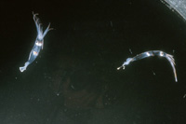 | Squid | Chiroteuthis calyx | Mollusca | Class Cephalopoda
B-6 | 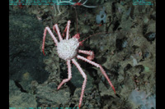 | Vermillion crab | Paralomis verrilli | Arthropoda | Class Crustacea  Order Decapoda
B-7 | 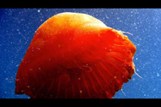 | Jelly  Scyphomedusa | Poralia rufescens | Cnidaria | Class Scyphozoa
B-8 | 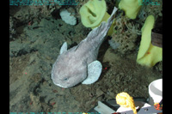 | Blob sculpin | Psychrolutes phrictus | Chordata | Class Osteichthyes
B-9 | 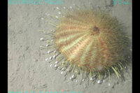 | Sea urchin | Tromikosoma sp. | Echinodermata | Class Echinoidea
B-10 | 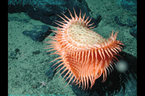 | Flytrap anemone |  | Cnidaria | Class Anthozoa  Family Hormathiidae
B-11 | 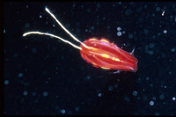 | Cydippid comb jelly |  | Ctenophora | Order Cydippida
B-12 | 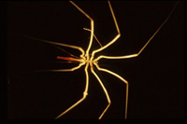 | Sea spider |  | Arthropoda | Class Pycnogonida
C-1 | 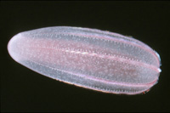 | Comb jelly | Beroe sp. | Ctenophora | Class Nuda
C-2 | 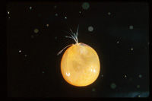 | Giant ostracod | Gigantocypris agassizii | Arthropoda | Class Crustacea  Order Ostracoda
C-3 | 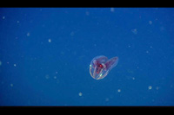 | Lobate comb jelly | Lampocteis sp. | Ctenophora | Order Lobata
C-4 | 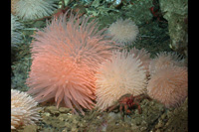 | Pom-pom anemone | Liponema brevicornis | Cnidaria | Class Anthozoa
C-5 | 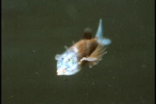 | Barreleye | Macropinna microstoma | Chordata | Class Osteichthyes
C-6 | 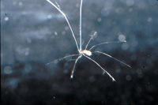 | Munnopsid isopod  Midwater spider | Munneurycope sp. | Arthropoda | Class Crustacea  Order Isopoda
C-7 | 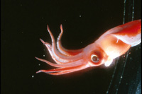 | Squid | Octopoteuthis deletron | Mollusca | Class Cephalopoda
C-8 | 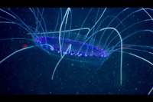 | Jelly  Hydromedusa | Solmissus sp. | Cnidaria | Class Hydrozoa  Subclass Narcomedusae
C-9 | 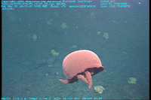 | Big red jelly  Scyphomedusa | Tiburonia granrojo | Cnidaria | Class Scyphozoa
C-10 | 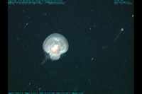 | Mystery mollusc |  | Mollusca | Class Gastropoda
C-11 | 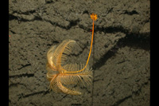 | Sea lily |  | Echinodermata | Class Crinoidea
C-12 | 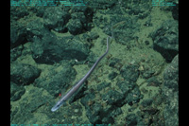 | Halosaur |  | Chordata | Class Osteichthyes
D-1 | 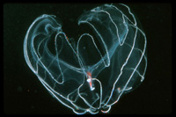 | Lobate comb jelly | Bathocyroe fosteri | Ctenophora | Order Lobata
D-2 | 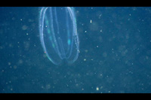 | Lobate comb jelly | Bolinopsis infundibulum | Ctenophora | Order Lobata
D-3 | 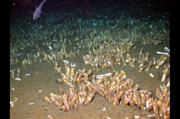 | Cold seep clams | Calyptogena spp. | Mollusca | Class Bivalvia
D-4 | 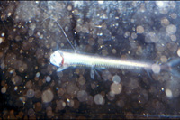 | Viper fish | Chauliodus macouni | Chordata | Class Osteichthyes
D-5 | 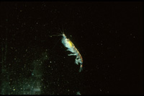 | Krill | Euphausia superba | Arthropoda | Class Crustacea  Order Euphausiacea
D-6 | 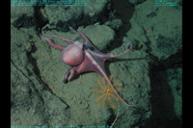 | Octopus | Graneledone sp. | Mollusca | Class Cephalopoda
D-7 | 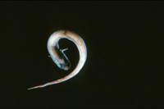 | Eelpout | Melanostigma pammelas  Lycodapus sp. | Chordata | Class Osteichthyes
D-8 | 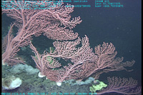 | Peppermint gorgonian | Paragorgia arborea | Cnidaria | Class Anthozoa
D-9 | 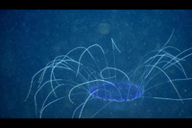 | Jelly  Hydromedusa | Solmissus sp. | Cnidaria | Class Hydrozoa  Subclass Narcomedusae
D-10 | 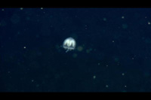 | Jelly |  | Cnidaria
D-11 | 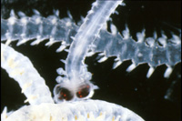 | Alciopid worm |  | Annelida | Class Polychaeta
D-12 | 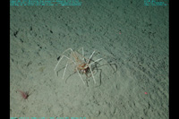 | Sea spider |  | Arthropoda | Class Pycnogonida

