
Microbes are a BLAST

Summary
This lesson provides students with an opportunity to explore the diversity of microbes in the marine environment. Through classification activities, students will gain an understanding of the challenges in identifying and understanding microbes. Students will use DNA sequences to identify relatedness between microbes using phylogenetic trees, then identify the role of specific microbes by searching for the presence of functional genes. A final product will allow students to communicate conclusions based on DNA evidence and research.
They will be using both SeaView (software to compare genetic sequences between organisms) and BLAST (online software to search a genome for a specific function)
Key Concepts
- MS-LS1.A: Structure and Function
  - All cells contain genetic information in the form of DNA molecules. Genes are regions in the DNA that contain the instructions that code for the formation of proteins, which carry out most of the work of cells.
- HS-LS2.C: Ecosystem Dynamics, Functioning, and Resilience
  - Biodiversity describes the variety of species found in Earth’s terrestrial and oceanic ecosystems. The completeness or integrity of an ecosystem’s biodiversity is often used as a measure of its health.
- HS-LS4.A: Evidence of Common Ancestry and Diversity
  - Genetic information, like the fossil record, provides evidence of evolution. DNA sequences vary among species, but there are many overlaps; in fact, the ongoing branching that produces multiple lines of descent can be inferred by comparing the DNA sequences of different organisms. Such information is also derivable from the similarities and differences in amino acid sequences and from anatomical and embryological evidence.
Objectives
The student will be able to:
- Determine which characteristics are useful in sorting or classifying items
- Create and explain a classification scheme using deep-sea organisms
- Use genetic sequences to create phylogenetic trees using the SeaView program.
- Demonstrate the ability to use the BLAST program to search an organism’s genome for specific functional genes.
- Research and record information about specific microbes
- Draw conclusions to communicate the various ecological roles that microbes play in the ocean
Materials
- Computers with internet access (one per student or student group)
- Set of Microbe Sort cards (one per group of two to four students)
- SeaView Software programs to be downloaded to computers (available free on line, URL found in procedure)
Procedure
PART ONE: Exploration (Microbe Picture Sort)
- To introduce the topic (and challenge) of classifying microbes to the students, have them sort pictures of microbes. The pictures the students will use include the microbes that are used in this lesson.
- Divide the students into small groups (2-4) and give each group a set of the pictures (Pictures can be found in the file titled “images for microbe sort”).
- Ask the groups to work together to sort the microbes in the pictures. The students can choose to sort however they like, but they must have a rationale for their groupings that they can explain to the class.
- Monitor group progress and allow all groups enough time to discuss sorting options and come to an agreement.
- Once all groups have groups have finished sorting their microbes, have each group explain their rationale for grouping the microbes as they did. Allow students from other groups to ask questions during or after explanations.
- Ask the students if they think scientists would sort/group the microbes the same way they did. (Answers may vary, but it is likely that students will recognize that their sorting method does not acknowledge important characteristics of the microbes. If not, ask questions to guide students to this idea.)
- Ask the students what characteristics scientists might use to sort/group the microbes. (Responses may include: prokaryote/eukaryote, function/energy source, etc.) **(If students have trouble with this question, ask what types of microbes they can think of. Responses should include: bacteria, phytoplankton, zooplankton, cyanobacteria, diatoms, etc.)**
- Have students discuss the value and challenge to sorting organisms based on physical characteristics. (Classifying based on physical or external characteristics ignores everything going on internally. For example, if the students were given pictures of other students in their class, they may sort the photos based on hair color or skin color, but cannot sort based on talent. In order to classify organism based on a functional trait, other information is required. This is where DNA comes in…)
PART TWO: Microbe Personality Quiz
- Explain to the students that they will be completing a personality to quiz to determine which microbe they are most like. In doing this, they will be introduced to some physical characteristics and functions of microbes.
- Have the students complete the Microbe Personality Quiz from the C-MORE website (http://cmore.soest.hawaii.edu/education/kidskorner/microbe_quiz.htm) If computers are available, the students can complete the quiz on the website; if not, the questions can be pre-printed for the students from the flipbook.
- Once all students have completed the quiz, ask them to read the given information about the microbe they are most similar to.
- Have the students use the given information to explain the purpose of each question they answered in the quiz (what characteristic does the question use to classify the microbe?). (Students can refer to the online or printed quiz; they must answer exactly as they did the first time.)
- Ask student volunteers to share their results. After each student shares, ask if any other students also got the same result.
- Results can be recorded on the board if desired. (You can write the name of the microbe on the board and keep tallies for other students who share the result, or you can put up pictures of each microbe and put student’s names next to the microbe they were found to be most similar to. Microbe Personality Cards are available on the EARTH lesson plan page to print and distribute.) Discuss the diversity of microbes represented in the class, and how this can begin to show how diverse microbes are.
- Once students have explained each question they answered, provide them with a copy of the dichotomous key (available in English and Spanish at the bottom of the quiz page: http://cmore.soest.hawaii.edu/education/kidskorner/microbe_quiz.htm
- Give each student a picture of a microbe from the Microbe Picture Sort and ask them to use the dichotomous key to identify the microbe.
- Allow the students time to work with the dichotomous key. Encourage them to think critically as they run into problems (don’t allow them to give up immediately).
- Once the students have spent a fair amount of time working with the dichotomous keys but all have run into problems, reconvene as a class and ask the students why they are having problems. (Reponses should indicate that the students did not know many things about their microbe just from looking at a picture.)
- Ask the students how they might find out some of that information about the microbes so that they can classify them. (Answers will vary, but make sure students remember that microbes are microscopic! Also, make sure students understand that microbes can live in all kinds of environments, including those that cannot be accessed by humans. Eventually, the students should suggest that DNA/genes would be a good source of information about an organism that cannot be seen.)

PART THREE: DNA Sequences and Phylogenic Trees
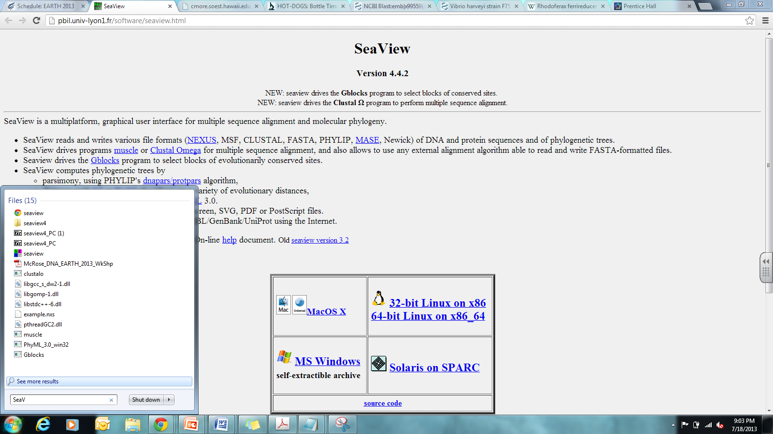
- Download software needed for the activity.
Go to http://pbil.univ-lyon1.fr/software/seaview.html to download the
software for PC or Mac
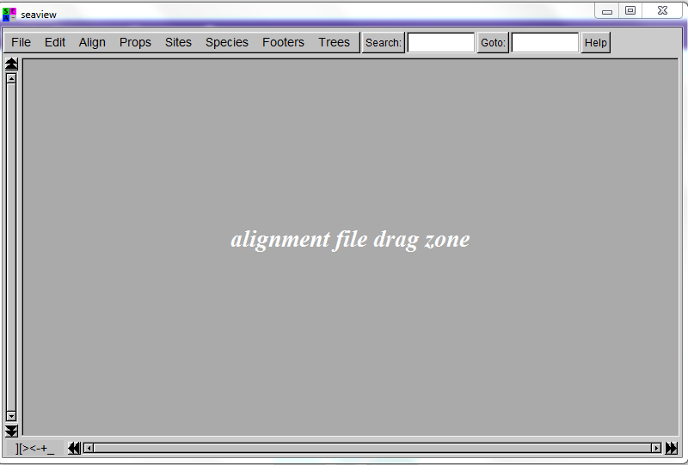
- Once the SeaView is loaded onto your computer, open it by clicking on the SeaView icon. The window below will pop up (you will want to make it smaller so that you can see the rest of your screen)

- Download the “16S_rRNA sequences” text file from the EARTH lesson plan page and drag it into the SeaView window on your computer. You will see the genes for all eight microbes that code for the 16S rRNA protein.
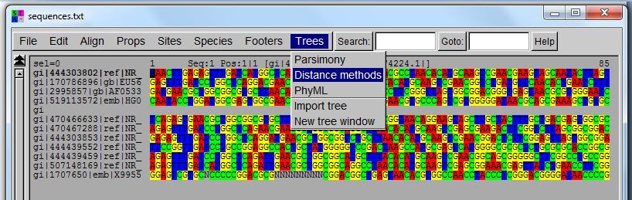

- From the menu, click on TREES, select Distance Methods
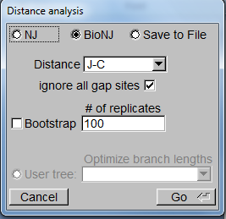
- The following pop up should appear
(make sure “ignore all gap sites” is checked)
- Click “Go” and your phylogenic tree will appear. To record the phylogenic tree, save it as a pdf or print it out.
- Answer the following questions in your lab book.
  - Which organism is the least closely related to the rest? Support your answer.
  - Would Prochlorococcus be more closely related to Synechococcus or Trichodesmium? Support your answer.
  - For the original sorting activity, into how many different groups did you separate your organisms? How does this compare to what your phylogenic tree shows? Why do you think there are differences?

PART FOUR: Microbial Ecological Roles
- Explain to students that they will be using genetic information to learn about individual microbes and their roles in their environments. Tell students they will focus on microbes that fall into three different categories based on their functions; they may be nitrogen-fixers, photosynthesizers, or heterotrophs.
- Give each student a copy of the “Microbial Ecological Roles” worksheet. Students should work individually or in groups – this will depend on the amount of computers available.
- Students will begin by conducting a BLAST search for functional genes for nitrogen fixation and photosynthesis in 3 different microbes. They must do this one microbe at a time. Detailed instructions and images can be found on the student worksheet. Data for this part will be recorded on the worksheet.
- Next, students will use what they learned about the function of each microbe AND conduct their own research to describe the location where each microbe is found in the ocean, where the microbe fits into the food web or biogeological cycles, and the overall role of the microbe. A list of sources can be found in the “Additional Resources” section of this lesson plan, as well as on the EARTH lesson plan page.
- To conclude, students will create a final product to illustrate/communicate their conclusions. The format of the product can be a poster, presentation, brochure, etc. Detailed criteria for the product and grading rubric are included in the student worksheet.
- If time allows, or if desired, students can present their final products.
Assessment
Both product and performance assessments are included in the Four Parts above
Additional Resources
- 'Microbial dark matter' mapped, Science Alert (07/13)
http://sciencealert.com.au/news/20131607-24580.html
- Microbe Personality Quiz has the online personality quiz and dichotomous key
http://cmore.soest.hawaii.edu/education/kidskorner/microbe_quiz.htm
- Microbe Wiki
  - Synechococcus: http://microbewiki.kenyon.edu/index.php/Synechococcus
  - Trichodesmium: http://microbewiki.kenyon.edu/index.php/Trichodesmium
  - Pelagibacter ubique: http://microbewiki.kenyon.edu/index.php/Pelagibacter_ubique
- Cyanobacteriology at WHOI
  - Trichodesmium: http://www.whoi.edu/science/B/people/ewebb/Tricho.html
  - Marine Synechococcus: http://www.whoi.edu/science/B/people/ewebb/Syne.html
- Mote Marine Labs: Trichodesmium: http://www.mote.org/index.php?src=gendocs&ref=Environmental%20Update%2C%20trichodesmium&category=Main
- Joint Genome Institute
Trichodesmium erythraeum: http://genome.jgi-psf.org/trier/trier.home.html
- Synechococcus elongates: http://genome.jgi-psf.org/synel/synel.home.html

